Materials
This retrospective cohort study comprised two independent institutional cohorts: an internal cohort from Gangnam Severance Hospital and an external cohort from Sinchon Severance Hospital. Because the two cohorts were drawn from different hospitals and different scanner populations, the model trained on the internal cohort was applied, without retraining, to the external cohort to assess external validity, following established internal/external validation principles for clinical prediction models [1-3]. CT examinations were performed between January 2018 and June 2020 for the internal cohort and throughout 2019 for the external cohort.
Inclusion criteria were as follows:
- Both clinical data and an abdominal CT examination were available for the same patient.
- Only CT examinations acquired at a tube voltage of 100 kVp were included; in the internal cohort, patients were further restricted to those scanned on the four most commonly used CT scanner models at that site, namely Siemens Sensation 64, GE Revolution CT, Philips Ingenuity Core 128, and Siemens SOMATOM Definition AS+, whereas in the external cohort no scanner-model restriction was applied except exclusion of the negligibly represented Canon scanners, of which only three were present.
- Patients younger than 20 years of age were excluded from both cohorts.
After application of these criteria, the final study population consisted of 1,079 patients in the internal cohort and 922 patients in the external cohort; the patient selection process for both cohorts is summarized in Figure 1.
Figure 1. Flow diagram of patient selection for the internal and external cohorts.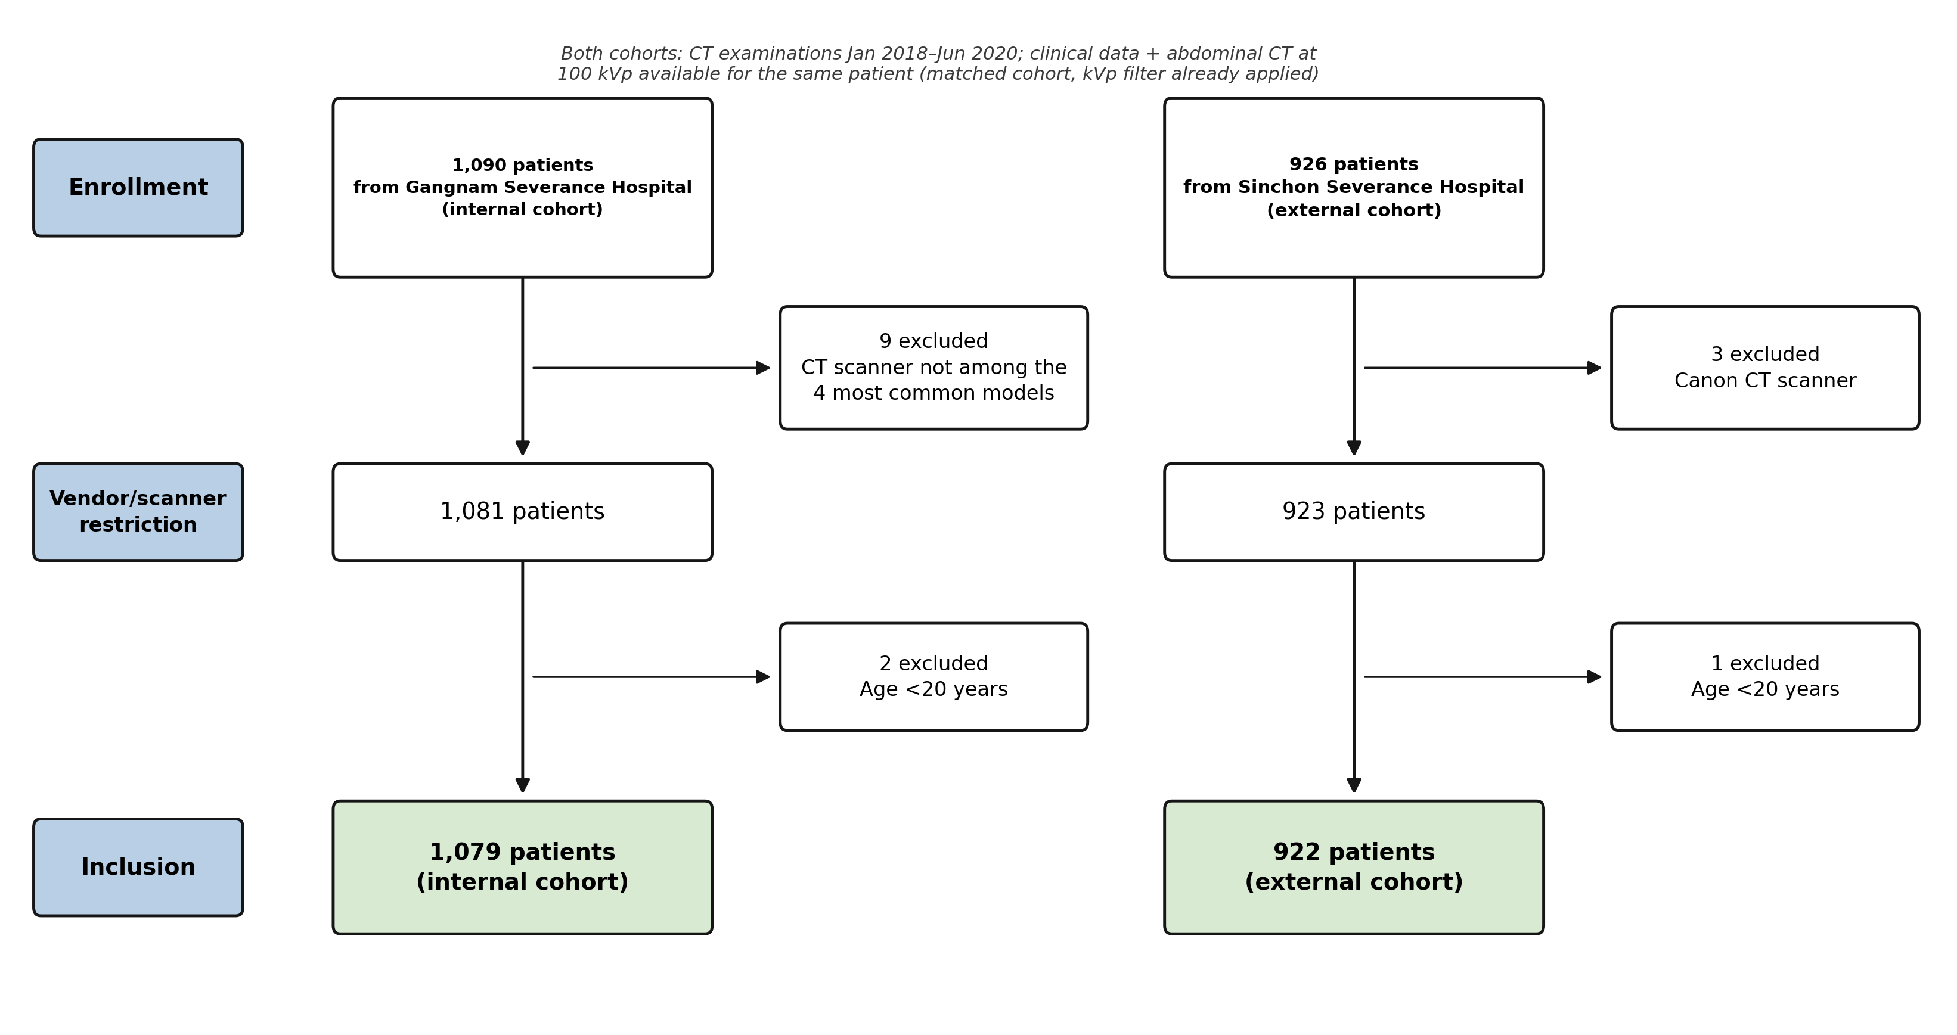
Age, sex, height, and weight were abstracted from the same clinical database used for patient matching and served as the baseline clinical predictors, collectively termed clinic4. Outcomes were defined as the presence or absence of a documented diagnosis of hypertension, diabetes mellitus, and chronic kidney disease — HTN, DM, and CKD, respectively — in the clinical database. Hypertension was present in 324 of 1,079 internal patients (30.0%) and 424 of 922 external patients (46.0%); diabetes mellitus in 202 internal patients (18.7%) and 285 external patients (30.9%); and chronic kidney disease in 83 internal patients (7.7%) and 168 external patients (18.2%).
Baseline characteristics of the internal and external cohorts are summarized in Table 1. There were no missing values for age, sex, height, weight, BMI, comorbidity, or scanner vendor in either cohort.
Table 1. Baseline Characteristics of the Patients
Characteristic | Internal cohort  (n = 1,079) | External cohort  (n = 922) | p-value
Age, years, mean ± SD | 57.1 ± 12.1 | 59.5 ± 12.7 | <0.001
Age, years, range | 20–91 | 20–90
Sex, n (%) |  |  | <0.001
— Female | 692 (64.1) | 497 (53.9)
— Male | 387 (35.9) | 425 (46.1)
Height, cm, mean ± SD | 162.2 ± 8.2 | 162.5 ± 8.6 | 0.401
Weight, kg, mean ± SD | 61.9 ± 10.6 | 61.8 ± 11.4 | 0.873
BMI, kg/m², mean ± SD | 23.5 ± 3.1 | 23.3 ± 3.4 | 0.383
Hypertension, n (%) | 324 (30.0) | 424 (46.0) | <0.001
Diabetes mellitus, n (%) | 202 (18.7) | 285 (30.9) | <0.001
Chronic kidney disease, n (%) | 83 (7.7) | 168 (18.2) | <0.001
CT scanner vendor, n (%) |  |  | <0.001
— Siemens | 560 (51.9) | 568 (61.6)
— GE | 317 (29.4) | 219 (23.8)
— Philips | 202 (18.7) | 135 (14.6)

AEC modulates the tube current (mA) along the craniocaudal z-axis during each abdominal CT acquisition, keeping image noise roughly constant from slice to slice. Because the current needed to achieve this depends on how much the patient attenuates the beam at each position, the resulting tube-current modulation curve carries information about the patient's cross-sectional attenuation, and by extension body habitus, at each slice position. We represented this curve at a fixed length of 128 points per patient, termed AEC-128, and used it as the imaging-derived predictor in this study.

Methods

AEC-128 Construction
To construct the fixed-length AEC-128 feature, the axial source series was first identified for each patient, excluding coronal/sagittal reformations, scout images, and dose reports, based on slice count, DICOM Image Type, Series Description, and image orientation. An open-source, deep-learning-based segmentation tool, Total Segmentator [4], was then applied to localize the liver and the bilateral hip bones, with the cranial-most liver slice and caudal-most hip slice defining the upper and lower boundaries of the analysis range; segmentation was used solely for this anatomical landmark localization, while tube-current values themselves were obtained directly from the DICOM header field X Ray Tube Current. Tube-current values within this hip-bone-to-liver range were extracted in craniocaudal order, and because the resulting slice count varied across patients, each sequence was resampled by linear interpolation to a fixed length of 128 points, yielding the AEC-128 curve used as the analytic unit in subsequent modeling.

Clinical Baseline Model
For each disease outcome, we fit a baseline logistic regression model, termed clinic4, using the four clinical predictors introduced above — age, sex, height, and weight — since these are the clinical variables routinely available at the time of imaging and therefore give a realistic baseline against which any imaging-derived contribution can be judged. Sex, being binary, was entered directly as a 0/1 indicator without scaling; age, height, and weight, being continuous and on different physical scales, were standardized to zero mean and unit variance using a scaler fit on the internal cohort and applied, without refitting, to the external cohort, so that no single variable would dominate the regression by scale alone. We evaluated this baseline by internal AUC under 5-fold stratified cross-validation — reduced to as few as two folds for outcomes whose minority class contained fewer than five patients — and by external frozen AUC for HTN, DM, and CKD; together these numbers served as the reference against which the incremental value of AEC-128 was assessed.

AEC-Derived Features
Raw AEC-128 curves were used without further normalization, since this variation already enters through clinic4 and an additional cohort-level scaling step risked removing the body-habitus signal that AEC-128 is intended to capture. Derived AEC features, described below, were standardized with their own scaler, fit on the internal cohort and applied frozen to the external cohort, kept separate from the clinical-feature scaler so that features on different physical scales did not dominate the L2-regularized logistic regression.
Three curve-level summary statistics were additionally computed per patient directly from the 128-point curve, following standard practice in time-series feature extraction [5]. The standard deviation, or SD, across all 128 points captured the overall range of tube-current modulation. The skewness of the point distribution captured the asymmetry of the modulation profile along the craniocaudal axis. The ratio of the mean tube current in the cranial half of the curve to that in the caudal half captured the relative attenuation burden of the upper versus lower abdomen.
Component scores from the functional principal component analysis described below, PC1 through PC3, were included as a fourth AEC feature candidate, providing a lower-dimensional representation of curve shape beyond these three summary statistics; during internal cross-validation, PCA was refit on each training fold and the resulting transform applied to the held-out fold, to prevent validation-curve information from leaking into the component estimation.

Functional Principal Component Analysis
The AEC-128 curve is a 128-dimensional variable per patient, but adjacent points are strongly autocorrelated, making it a functional data object rather than a set of independent measurements. Entering all 128 points as independent variables would incur substantial multicollinearity and overfitting risk; functional principal component analysis, abbreviated FPCA [6], was therefore applied to summarize the curve's shape information in a lower-dimensional form. FPCA extends the principle of principal component analysis, or PCA, to functional data, approximating each curve as a linear combination of a mean curve and a series of orthogonal components that explain the greatest inter-curve variation; each patient's curve is then summarized by its projection onto these components, the component score, or FPC score.
The specific procedure is as follows. First, the mean curve μ(z) was calculated from the overall curve of the internal cohort, and the deviation curve dᵢ(z) = xᵢ(z) - μ(z) was obtained from each patient's curve. We then solved the 128 × 128 covariance matrix C of the shifted curves using the singular value decomposition (SVD) [7], and for numerical stability, we directly used the PCA implementation from scikit-learn. Through this decomposition, we obtain the form C ≈ ΦΛΦᵀ, where Φ is a 128×k row matrix with the maintained orthonormal eigenvectors, that is, the eigenelements (the eigenfunction, φₖ), as column vectors, and Λ is a k×k diagonal matrix composed of the eigenvalues (λₖ) sorted in descending order of the explained variance ratio. The number k of components to be retained is chosen based on the elbow, as explained later, and if the data is truncated to keep only the top k components, it becomes the rank-k approximation of C used for evaluating the quality of subsequent reconstruction. Finally, each patient's deviation curve was projected onto each component to calculate the component scores sᵢ,ₖ = Σ z dᵢ(z)·φₖ(z)).

Figure 2. Computation of FPCA on the internal-cohort AEC-128 curves.
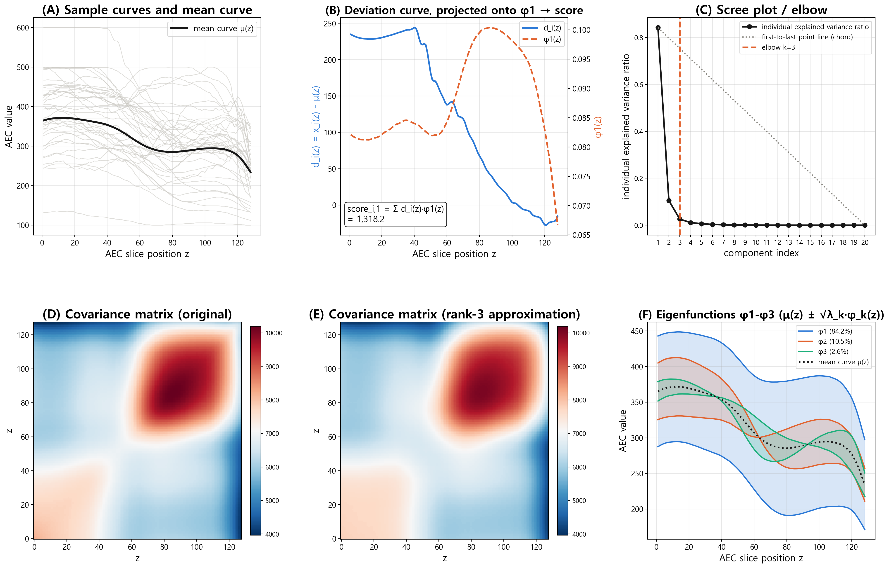(A) A random sample of patient curves, shown in gray, and the resulting mean curve μ(z), shown in black. (B) Deviation curve dᵢ(z) = xᵢ(z) − μ(z) for a representative patient, projected onto φ₁ to yield the component score scoreᵢ,₁ = Σᵩ dᵢ(z)φ₁(z) = 1,318. (C) The eigenvalue scree plot used for elbow-based component selection, with k = 3. (D, E) The 128×128 covariance matrix, eigen-decomposed via SVD to obtain (F) the resulting eigenfunctions φ₁–φ₃, shown as μ(z) ± √λₖ·φₖ(z).
As a fitting result for the internal cohort, PC1 alone explained 84.2% of the total variance, PC1–2 explained 94.7% cumulatively, and PC1–3 explained 97.3% cumulatively. The number of components to be retained was determined by applying the Kneedle algorithm [8] to the variance scree plot. After normalizing the component index and the individual explanation variance ratio to the range of 0–1, the method defines the point with the maximum perpendicular distance from the line connecting the first and last components as an elbow. Since this elbow corresponds to PC3, the three-component scores of PC1–PC3 were adopted as the PC score of the AEC curve.
The component, that is, the eigenfunction, was estimated only in the internal cohomotopy. Subsequently, the curves of the external cohort were projected onto this same fixed component without refitting to obtain a component score, enabling the two cohorts to be compared on an equal basis. This captures morphological variation in curve shape that individual summary statistics such as the mean, SD, or skewness do not capture on their own; it enters the predictive models as an input variable, consistent with prior applications of FPCA to CT-derived curves for clinical outcome prediction [9].

AEC Feature Selection and Evaluation
Five AEC feature candidates were compared as additions to clinic4: SD alone, skewness alone, the upper/lower ratio alone, FPCA scores alone, and all shape features combined with FPCA scores. For each disease, all five candidates were evaluated by internal AUC under the same 5-fold stratified cross-validation scheme, using logistic regression [10], and the candidate with the highest mean internal AUC was selected independently for that disease, since the shape of the AEC-clinical association was not assumed to be shared across HTN, DM, and CKD. External data played no role in this selection: model comparison relied on internal cross-validation only, and the external cohort was reserved for a single, frozen final evaluation of the selected model, consistent with the internal/external validation roles described above.
For each disease, a model combining the highest-performing AEC feature set with clinic4 was compared to clinic4 and the internal out-of-fold AUC, as well as the external AUC of an internally trained model applied once without retraining, following the two-cohort clinic-model versus clinic+curve-model design used in the prior curve-based disease prediction study [11]. Since the two models were evaluated on the same patient set, the difference in their AUCs was tested using a paired DeLong test [12]. The classification threshold was fixed at the point that maximized Youden's J statistic [13] in the internal out-of-fold prediction, and this threshold was applied identically to the calculation of sensitivity, specificity, and accuracy for both cohorts. To verify whether AEC contributions were consistent across CT manufacturers, AUC was additionally calculated using the same fixed threshold for each scanner subgroup, including more than 30 patients with both of the two outcome classes present.

References
1. Steyerberg EW. Clinical Prediction Models: A Practical Approach to Development, Validation, and Updating. 2nd ed. Springer; 2019.
2. Moons KG, Altman DG, Reitsma JB, et al. Transparent reporting of a multivariable prediction model for individual prognosis or diagnosis (TRIPOD): explanation and elaboration. Ann Intern Med. 2015;162(1):W1-W73. doi:10.7326/M14-0698
3. Ramspek CL, Jager KJ, Dekker FW, Zoccali C, van Diepen M. External validation of prognostic models: what, why, how, when and where? Clin Kidney J. 2021;14(1):49-58. doi:10.1093/ckj/sfaa188
4. Wasserthal J, Breit HC, Meyer MT, et al. TotalSegmentator: robust segmentation of 104 anatomic structures in CT images. Radiol Artif Intell. 2023;5(5):e230024. doi:10.1148/ryai.230024
5. Barandas M, Folgado D, Fernandes L, et al. TSFEL: time series feature extraction library. SoftwareX. 2020;11:100456. doi:10.1016/j.softx.2020.100456
6. Ramsay JO, Silverman BW. Functional Data Analysis. 2nd ed. Springer; 2005.
7. Eckart C, Young G. The approximation of one matrix by another of lower rank. Psychometrika. 1936;1(3):211-218. doi:10.1007/BF02288367
8. Satopaa V, Albrecht J, Irwin D, Raghavan B. Finding a "Kneedle" in a haystack: detecting knee points in system behavior. In: 2011 31st International Conference on Distributed Computing Systems Workshops. IEEE; 2011:166-171. doi:10.1109/ICDCSW.2011.20
9. Shalmon T, Salazar P, Horie M, et al. Predefined and data driven CT densitometric features predict critical illness and hospital length of stay in COVID-19 patients. Sci Rep. 2022;12(1):8143. doi:10.1038/s41598-022-12311-4
10. Kohavi R. A study of cross-validation and bootstrap for accuracy estimation and model selection. In: Proceedings of the 14th International Joint Conference on Artificial Intelligence. 1995:1137-1143.
11. Jeon ET, Park H, Lee JK, et al. Deep learning-based COPD exacerbation prediction using flow-volume and volume-time curve imaging: retrospective cohort study. J Med Internet Res. 2025;27:e69785. doi:10.2196/69785
12. DeLong ER, DeLong DM, Clarke-Pearson DL. Comparing the areas under two or more correlated receiver operating characteristic curves: a nonparametric approach. Biometrics. 1988;44(3):837-845. doi:10.2307/2531595
13. Youden WJ. Index for rating diagnostic tests. Cancer. 1950;3(1):32-35. doi:10.1002/1097-0142(1950)3:1<32::AID-CNCR2820030106>3.0.CO;2-3

